ARYAMAN MISHRA

19BCE1027

Multiple Shapes in C(with proof of Code in Turbo C++)

Single Line:

#include<graphics.h>

#include<stdio.h>

#include<conio.h>

void main(void){

int gdriver=DETECT,gmode;

int x1=200,y1=200;

int x2=300,y2=300;

clrscr();

initgraph(&gdriver,&gmode,"c:\\turboc3\\bgi");

line(x1,y1,x2,y2);

getch();

closegraph();

}

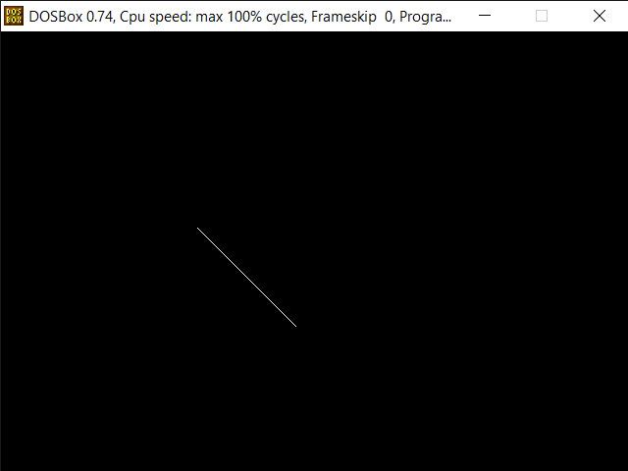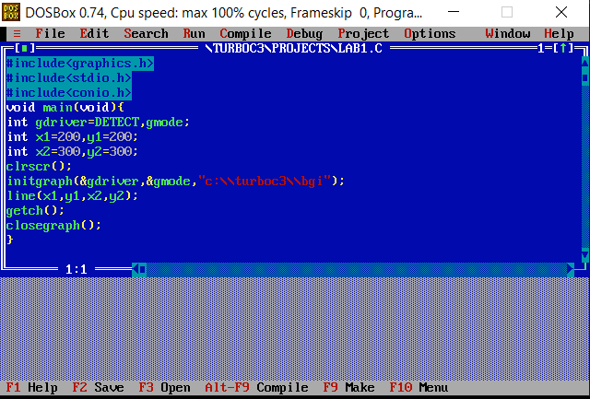

Multiple Lines:

#include<stdio.h>

#include<graphics.h>

#include<conio.h>

int main()

{

int gd=DETECT,gm;

initgraph(&gd,&gm,"c:\\turboc3\\bgi");

line(150,150,450,150);

line(150,200,450,200);

line(150,250,450,250);

getch();

closegraph();

return 0;

}

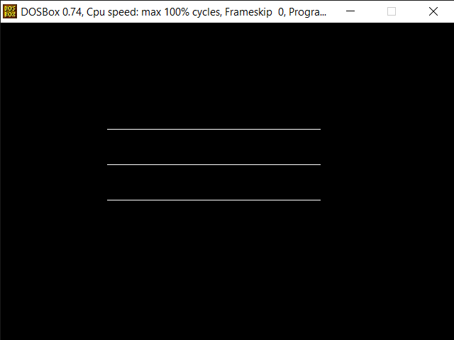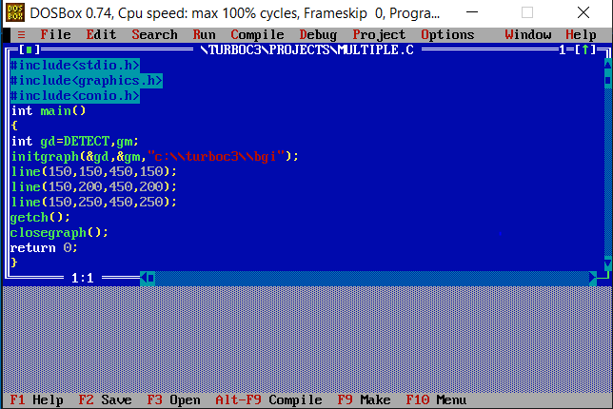

Rectangle:

#include<stdio.h>

#include<graphics.h>

#include<conio.h>

int main()

{

int gd = DETECT, gm;

int left = 150, top = 150;

int right = 450, bottom = 450;

initgraph(&gd, &gm, "c:\\turboc3\\bgi");

rectangle(left, top, right, bottom);

getch();

closegraph();

return 0;

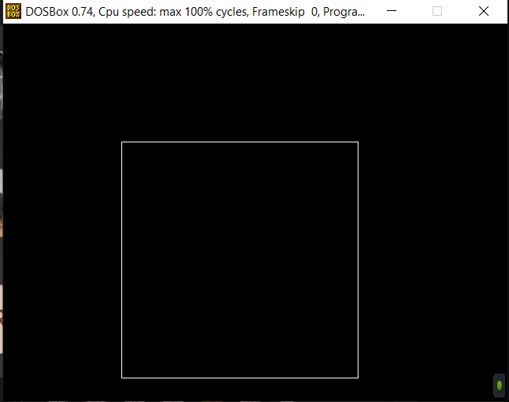}

Circle:

#include<stdio.h>

#include<graphics.h>

#include<conio.h>

int main()

{

int gd = DETECT, gm;

initgraph(&gd, &gm, "c:\\turboc3\\bgi");

circle(250, 200, 50);

getch();

closegraph();

return 0;}

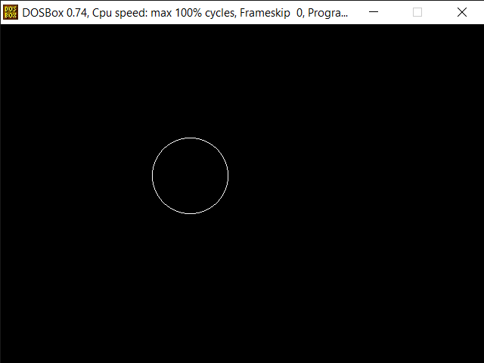

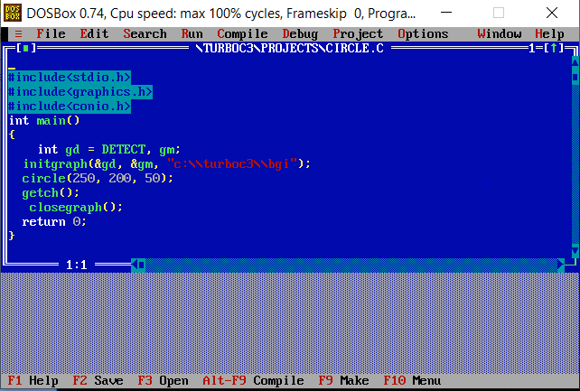

Arc:

#include<stdio.h>

#include<graphics.h>

#include<conio.h>

int main(){

int gd = DETECT, gm;

int x = 250;

int y = 250;

int start_angle = 155;

int end_angle = 300;

int radius = 100;

initgraph(&gd, &gm, "c:\\turboc3\\bgi");

arc(x, y, start_angle, end_angle, radius);

getch();

closegraph();

return 0;

}

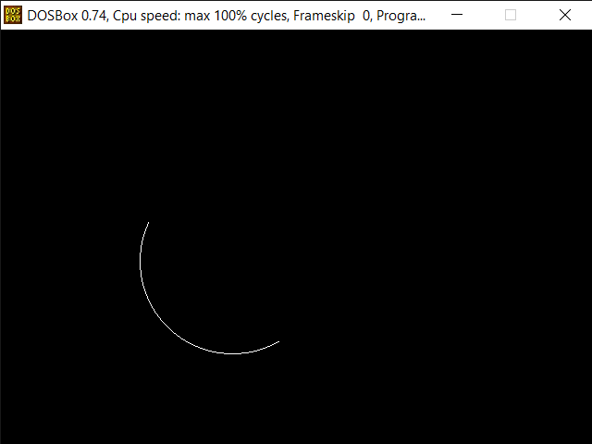

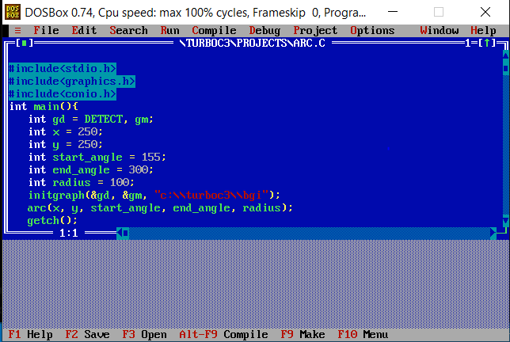

Hut:

#include<stdio.h>

#include<conio.h>

#include<graphics.h>

void main()

{

int gd=DETECT,gm;

clrscr();

initgraph(&gd,&gm,"c:\\turboc3\\bgi");

setcolor(3);

line(100,200,300,200);

line(100,400,300,400);

line(100,400,100,200);

line(300,400,300,200);

line(300,200,500,200);

line(300,400,500,400);

line(500,200,500,400);

line(170,250,270,250);

line(170,200,270,200);

line(170,250,170,400);

line(270,250,270,400);

line(200,50,400,50);

line(400,50,500,200);

line(300,200,200,50);

line(100,200,200,50);

getch();

closegraph();

}

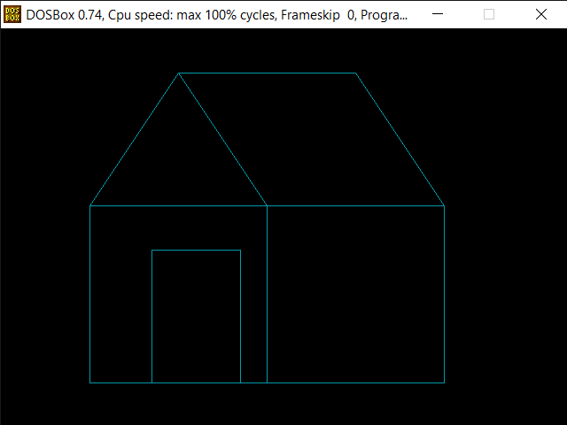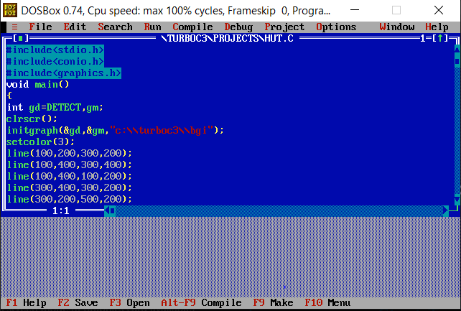

Fill Color:

#include<stdio.h>

#include<conio.h>

#include<graphics.h>

int main()

{

int gdriver = DETECT,gmode;

initgraph(&gdriver,&gmode,"c:\\turboc3\\bgi");

setfillstyle(SOLID_FILL,RED);

circle(200,200,50);

floodfill(202,202,15);

getch();

return 0;

}

